1.
Open Windows Defender Firewall settings on your computer and create a new outbound rule to block all traffic from the Spotify desktop app.

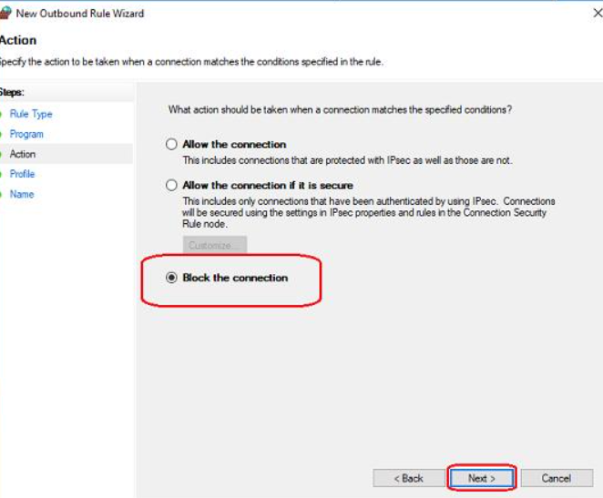
he selected Spotify executable's outbound connections are blocked by the rule. This does not necessarily block every Spotify-related process or other Spotify app components.

2.
Set up an inbound rule in Windows Defender Firewall to allow incoming connections only for Google Chrome on port 443 (HTTPS).
Objective: Create a firewall rule allowing incoming TCP connections on local port 443 for Google Chrome.
- Open wf.msc and select Inbound Rules.
- Click New Rule… and select Custom.
- Under Program, select This program path and browse to chrome.exe.
- Under Protocol and Ports, set:
  - Protocol type: TCP
  - Local port: 443
  - Remote port: Any
- Under Scope, leave the IP addresses unrestricted unless you need to limit trusted sources.
- Select Allow the connection.
- Select the required profiles: Domain, Private, and/or Public.
- Name the rule Allow Chrome Inbound TCP 443 and click Finish.

3.
Document, step-by-step, how you would block all traffic from a specific IP address (for example, 123.45.67.89) using Windows Defender Firewall.<br><br><em><strong>Hint:</strong> Use the 'Scope' tab when creating a new rule to specify the IP address.</em>
To block traffic in both directions, create two rules: one inbound and one outbound.
Step 1 — Create an inbound rule
Open wf.msc → Inbound Rules → New Rule → Custom. Select All programs and leave the protocol as Any.
Step 2 — Configure Scope
Open the Scope tab. Under Remote IP address, select These IP addresses → Add, then enter 123.45.67.89.
Step 3 — Block the connection
Select Block the connection, choose the appropriate profiles, name the rule Block IP Inbound, and click Finish.
Step 4 — Create an outbound rule
Repeat the process under Outbound Rules. In Scope, enter the same address under Remote IP address. Name the rule Block IP Outbound.

4.
Compare hardware firewalls (like those used in large offices) and software firewalls (like Windows Defender) by listing 3 key differences and a use case for each.
Feature | Hardware firewall | Software firewall
1. Location | A separate physical device on the network | Installed or built into a computer
2. Protection | Protects multiple devices across a network | Primarily protects the individual device
3. Management | Often managed centrally by network administrators | Configured on individual systems or centrally through management tools
Use case | Protecting an office network with many computers and servers | Blocking unwanted connections to a personal laptop using Windows Defender Firewall

